Below written by Nick at Banning California seminar
I was very excited to get the opportunity to host the seminar here in Banning California from October 23rd to 29th and I just wanted to thank Sifu and everyone who came out - Jim Doty, Colin Kane, Beth Trachtman, Matt Shachno, Ajay Kumra, Jonathan Douglas and his son Gideon, Hank Babcock, Michael Rollins - thank you all and it was a pleasure to have all of you here.
People drove in on Friday night and Saturday morning, and we started training in the early afternoon on Saturday. We started by going over the Little Nine Heaven exercises and animals. Sifu showed us the more advanced ways of practicing the forms which he said he has never taught before. He also told us that wanted us to learn to teach so that we could eventually teach the next generation of students. For this reason, were asked to correct each other. This was also in order to keep us in the habit of working together and helping each other without ego. After the afternoon's training, he awarded Jim Doty a certificate to recognize his 40 years of training with Sifu. I haven't even been alive that long, congratulations Jim! Ajay Kumra and I received Hsing-I and Splashing Hands Black Belt certificates as well. Thank you Sifu, it was truly an honor. After training, we took a break for dinner and some students traded acupressure massages. In the evening, we went over the uses for many various Chinese herbal recipes that Sifu was given by Master Hsu Hong Chi and we also learned advanced meditation techniques and chi kung. He said he has never showed these meditation techniques to anyone before. It was truly a special day and evening and I feel honored to have been there with all of you.
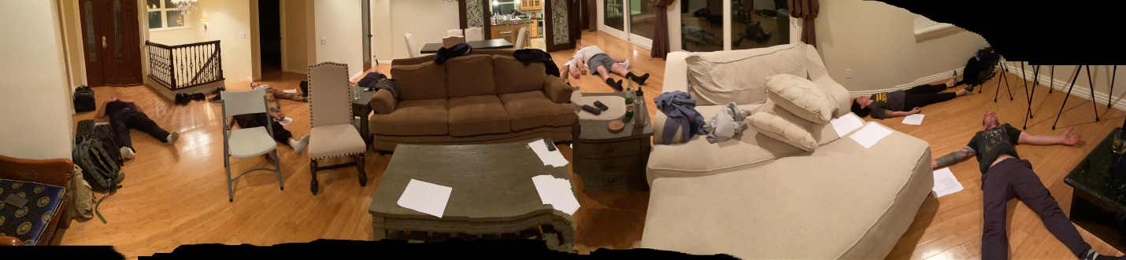
Special meditation never taught before

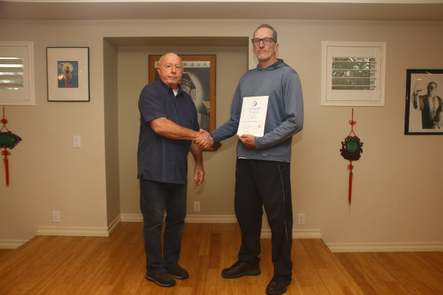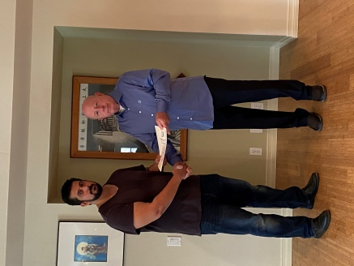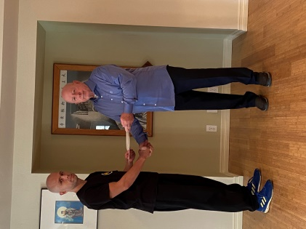
Jim Doty 40 years Ajay & Nice Black Belt Certificate
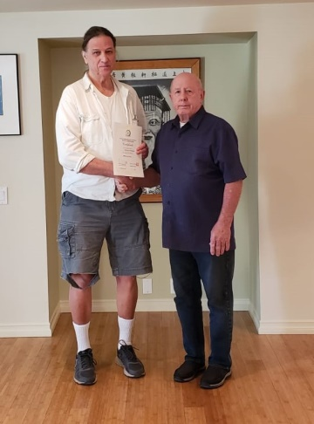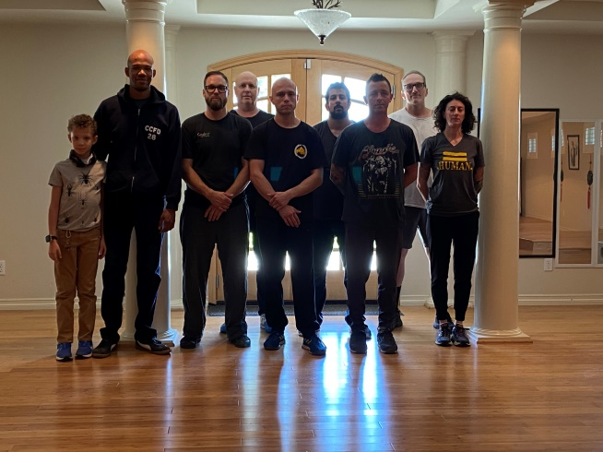
Hank 36 years Students who trained
We started back up again Sunday morning, practicing Little Nine Heaven and Chen Tai Chi, working to assimilate the new things we were being taught, getting corrections, and helping each other with the forms and asking questions. Sifu also checked most of the students' Shih Shui, looking for the one he wants to give the highest level of Shih Shui to, a level that he hasn’t taught before, so they can learn to teach. I was told Beth is learning the highest level of women’s Shih Shui, which he has never taught, but he said he also wants to teach other special women this magnificent art before he retires. After lunch, Ajay taught us Psychic Healing as Sifu looked on. On Monday, we trained in the morning again and then spent the afternoon in Palm Springs, taking a break to relax in the warm weather and going to a few bars. On Tuesday and Wednesday, Lao Tzu explained a special way of doing the Hsing-I forms and corrected our Little Nine Heaven and Tzu Men, as well as checking the Shih Shui of some of the students. Hank Babcock stopped by in the afternoon to train and we had some of his herbal wine and talked about Chinese herbs in which he is very knowledgeable. Hank also got a certificate for recognizing his 36 years of training and loyalty to L9H.
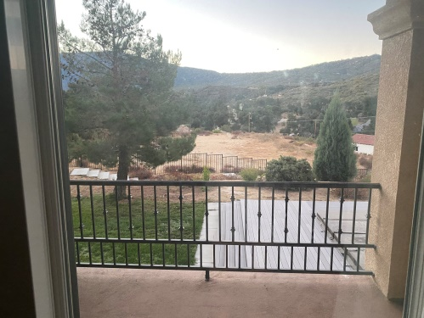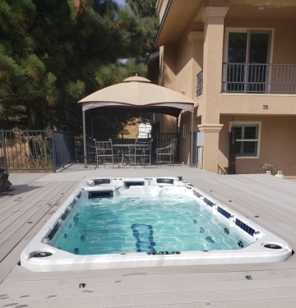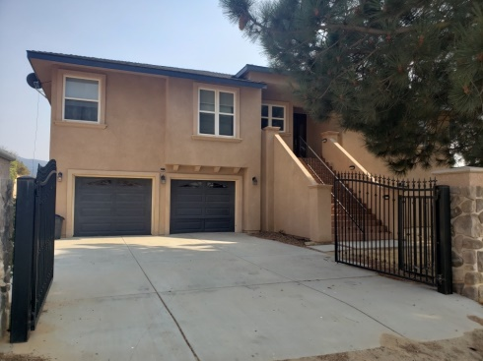
Looking toward mountains Summing Pool/Jacuzzi Front of house
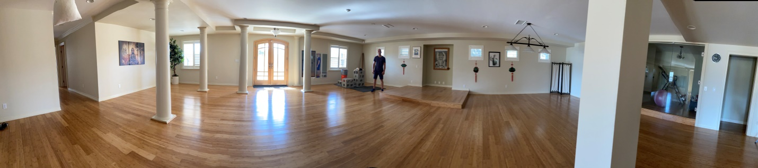
Large work out area for training
The last few students left on Thursday and, all in all, I think the seminar was a success. We all truly learned a lot and came away with many more things to practice. Thank you Sifu for teaching us and thank you everyone for coming. I'm really looking forward to the next one and to training with all of you again, I hope to see you all soon.
Nick
Sifu has many older students who have been with him for over 30 some years. Four of the local ones are Al Lam 45 years Jack Meeker (40 years), John Meiner (36 years), and Rick Collins (32 years). They still learn privately and visit Sifu often. They could not make the seminar because of various reasons. Sifu also gave them each a certificate to recognize their years of training and dedication to the Little Nine Heaven School.
Jack Meeker received a Special Certificate as he is blind and has been training with me for 40 years he has completed the courses in Splashing Hands, Iron Hand and Hsing-I he was given a Black Belts in both systems because he trains harder than many of my students. He trains every day and also teaches blind students.
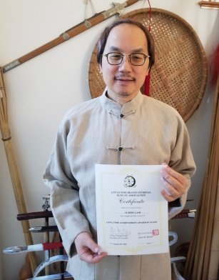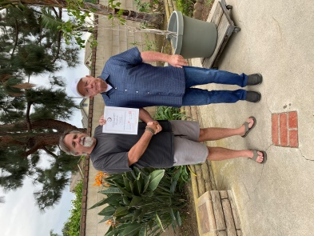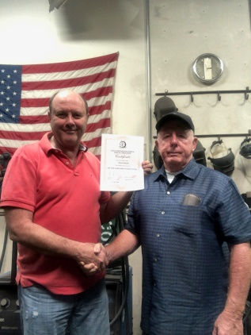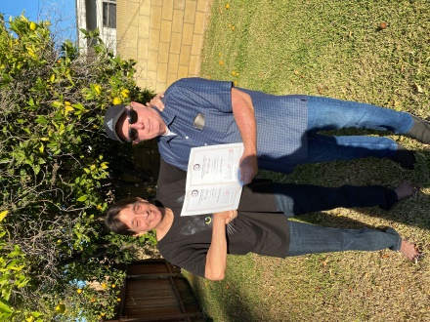
Al Lam 45 years John 36 years Rick 32 years Jack 40 years

